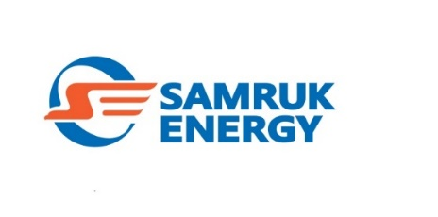 Message for Media
Supporting Kazakhstani manufacturers in procurement in energy sector
20.04.2020

Kazakhstani business entities, the products of which are oriented towards the use in the energy sector, are steadily developing challenging production projects. The key to the technological development of domestic companies and their manufacturing of products with higher added value has become the mechanism of so-called off-take agreements. 8 off-take agreements worth over 536 mln.tenge were concluded during 2019-2020 across “Samruk-Energy” JSC group of companies.
To supply its power plants, coal mines and power transmission companies, the largest electricity holding company formalized relations regarding the purchase of a wide range of goods - from radio stations and insulators to electrodes and transformers.
Off-take agreements is a good tool for giving support in respect of purchase orders for entrepreneurs that are involved in import substitution projects. It is a long-term contract under suspensive conditions of delivery and payment subject to the implementation of a project.
The evolvement of import substitution is a very important aspect of supporting domestic production. “Samruk-Energy” JSC established a Local project office for import substitution and development of local content, the result of which, in fact, was the above-mentioned 8 offtake agreements with Kazakhstani producers. At the same time, a particular attention is paid to the withdrawal of goods subject to import substitution from purchased works and services. So, “Alatau Zharyk Company” JSC, the energy transmission company in Samruk-Energy structure, withdrew the Transformer item, which is not produced in Kazakhstan, from the purchased works and provided a domestic supplier that established a production facility for this item with a purchase order for 485 mln.tenge
According to Darkhan Sagindykov, Managing Director for Procurement at “Samruk-Energy” JSC, the mechanism of off-take agreements is now actively being introduced into the procurement system of “Samruk-Kazyna” Fund, which will bring cooperation with domestic business to a fundamentally new level, and additionally create new jobs, and develop production, which previously has not existed in Kazakhstan.
As it is known, the Fund declared 2020 the Year of Support for Domestic Manufacturers. The Fund companies often act as major customers, providing jobs for a significant part of the trade, service and industrial sectors of the economy. Only from the beginning of 2020 “Samruk-Energy” JSC group’s electricity enterprises have provided domestic commodity producers with purchase orders worth more than 2,5 bn tenge.

Reference:
“Samruk-Energy” JSC is the largest power holding company in Kazakhstan, 100% owned by “Samruk-Kazyna” SWF JSC. It was established in 2007. Core business: electricity and heat production; transmission, distribution and sale of electricity, power coal mining. The holding company comprises energy and coal enterprises, including “Ekibastuz SDPP-1” LLP, “Ekibastuz SDPP-2 Plant” JSC, “Bogatyr Komir” LLP, “Almaty Power Plants” JSC, “Moynak Hydropower Plant named after U.D. Kantayev” JSC, “Shardarinsk HPP” JSC, etc.
______________________________________________
Government Relations and Communications Office of “Samruk-Energy” JSC.
Tel: (7172) 55-30-62; r.tasbulatov@samruk-energy.kz

