“Samruk-Energy” JSC management report on financial and economic operations based on 2016 results
- Group overview

“Samruk-Energy” joint-stock company (hereinafter –the Company) was established on April 18, 2007 by resolution of general meeting of founders in order to develop and implement a long-term state policy on upgrading of existing and introduction of new generating facilities. The founders of the Company at the time of its establishment were "Kazakhstan holding for management of state assets “Samruk” JSC and “KazTransGaz” JSC.The Company was registered on May 10, 2007.
As a result of reorganization effected through the merger of “Kazakhstan holding for management of state assets “Samruk” JSC and “Sustainable development fund “Kazyna” JSC, on November 3, 2008, the Company’s shareholder became “Sovereign Wealth Fund “Samruk-Kazyna” JSC, being the legal successor of “Kazakhstan holding for management of state assets “Samruk” JSC.
To date, the Company is the largest diversified holding company successfully integrated into the international energy mix, creating value for its shareholders and aimed at building highly efficient power supply system ensuring sustainable development of all Kazakhstan’s sectors.
The main types of activities of the Group are the production of electricity, heat and hot water based on coal, hydrocarbons and water resources and sales to the population and industrial enterprises, transportation of electricity and technical distribution of electricity in grids, construction of hydropower plants and thermal power plants, as well as rental of property complexes of hydropower plants, coal mining .
The Company’s assets include the largest generating companies, including plants of national importance such as Ekibastuz SDPP-1 and SDPP-2, as well as other plants producing heat and electricity in Almaty Region and in Aktobe city; the main hydropower plants of the Republic, parts of Irtysh cascade HPP and HPPs in the country’s southern regions (Shardarinsk and Moynak HPPs) are represented. The Company’s assets also include regional distribution networks and retail companies of Almaty Region, Mangistau, East Kazakhstan Region, and Kazakhstan’s biggest coal producer Bogatyr Komir LLP, which delivers coal to the Group’s generating facilities and third parties operating in Kazakhstan and Russia.

The following changes in macroeconomic indicators occurred during 2016 and 1 quarter of 2017:
- Consumer price index 108.50%;
- price index of industrial products producers 115.50%;

Change in fuel prices:

item | Measurement unit | 2015 | 2016 | %
Coal | tenge/tons | 1 598 | 1 709 | 107%
Gas incl transportations (as in the case of Almaty power plants) | tenge/м3 | 20 702 | 23 940 | 116%

Oil price (Brent) usd / bbl at the end of 2016 amounted to 56.82 usd / bbl with growth of 52.4% compared to the previous year. At the end of the first quarter of 2017, the price was 52.83 usd / bbl. (Source: https://www.bloomberg.com/quote/CO1:COM)
The operating activities of the Group's subsidiaries and joint companies which are natural monopoly and regulated markets entities and entities dominating in a competitive market, are governed by the laws of the Republic of Kazakhstan "On Electricity", "On Natural Monopolies and Regulated Markets", "On Competition" and the Code of the Republic of Kazakhstan "On Entrepreneurial Activity" newly entered into force in January 2016.
Tariff regulation depending on the business type of energy companies falls under the competence of the Committee for Regulation of Natural Monopolies and Competition Protection of the Republic of Kazakhstan Ministry of National Economy or Industry-specific ministry - the Ministry of Energy.
The following tariffs were in effect during the reporting period:
- for energy producing organizations (EPO), tariffs for 2016-2018 were maintained at the level of 2015 ceiling tariffs. The prospective introduction of the capacity market for EPO was postponed from 2016 to 2019 (by the order of the Minister of Energy d/d February 27, 2015 No.160 with amendments as of November 30, 2015). Ceiling tariffs for electricity and ceiling tariffs for the service on maintaining the availability of capacity for 2019-2025 were approved (Order of the Minister of Energy d/d 03.07.2015 No. 465 with amendments as of November 30, 2015). In the reporting period due to changes in the investment program and modernization of power plants, an individual tariff for "Moynak HPP" JSC to the level of 9,50 tenge / kWh was increased and an individual tariff for “Shardarinsk HPP” JSC at 9,50 tenge was approved with putting into force from January 1,2016.

Weighted average tariffs for electricity generation

Name | Measur.unit | 2015 actual | 2016 actual | 2017 plan | 2018 plan
“Ekibastuz SDPP-1” LLP | tenge/kWh | 7,73 | 7,33 | 7,51 | 7,85
“Ekibastuz SDPP-2” JSC | tenge/kWh | 8,66 | 6,68 | 7,23 | 7,18
“APP” JSC | tenge/kWh | 8,60 | 8,60 | 8,60 | 8,60
“Aktobe CHP” JSC | tenge/kWh | 7,29 | 7,30 | 7,30 | 7,30
“Shardarinsk HPP” JSC | tenge/kWh | 4,50 | 9,50 | 9,50 | 9,50
“Moynak HPP” JSC | tenge/kWh | 8,74 | 8,25 | 9,50 | 9,50

- for heat production by energy producing organizations, in compliance with the requirements of the legislation, a ceiling long-term tariff with putting into effect from 01.04.2016 for a term until 2020 was approved for “Aktobe CHP” JSC. In the reporting period tariffs as an ERM were approved for “APP” JSC due to the growth of prices for a strategic commodity: gas and its transportation; long-term ceiling tariffs were also approved with putting into effect from 01.04.2017 until 2021. Ceiling long-term tariffs were approved with the inclusion of investment components in tariffs.
Tariffs for heat production
Name | Measurement unit | 2015 actual | 2016 actual | 2017 plan | 2018 plan
“APP” JSC | tenge/kWh | 2 732 | 2 872 | 3 539 | 3 767
“Aktobe CHP” JSC | tenge/kWh | 1 167 | 1 532 | 1 959 | 2 212
“Ekibastuz SDPP-2” JSC | tenge/kWh | 686 | 683 | 708 | 708
“ZhSDPP” JSC | tenge/kWh | 1 050

- For regional power transmission companies (RPTC), ceiling long-term tariffs for the term until 2020 based on submitted tariff estimates were approved in 2016. Tariffs include investment programs for grid companies.

Tariffs for power transmission services
Name | Measurement unit | 2015 actual | 2016 actual | 2017 Plan | 2018 Plan
“AZhC” JSC | tenge/kWh | 5,21 | 5,35 | 5,83 | 6,04
“EK REC” JSC | tenge/kWh | 3,26 | 3,76 | 3,82 | 4,00
“MDPGC” JSC | tenge/kWh | 3,57 | 4,16 | 4,50 | 4,40

In the reporting period tariffs for energy supplying organizations (ESO) were approved by CRNM PC.
Tariffs for electricity sale by ESO
Name | Measurement unit | 2015 actual | 2016 actual | 2017 Plan | 2018 Plan
“AlmatyEnergoSbyt” LLP | tenge/kWh | 15,29 | 15,66 | 16,36 | 16,59
“ShygysEnergoTrade” LLP | tenge/kWh | 10,49 | 10,48 | 11,11 | 11,84

Main business lines of the Company are:
- Production of electricity;
- Production of heat;
- Transmission and distribution of electricity;
- Sale of electricity;
- Mining of power producing coal
The share of “Samruk-Energy” JSC in total power generation in the Republic of Kazakhstan in 2016 was 24%, compared to 2015 the share grew by 1%.
Production KPI (broken down by producers)
Subsidiary and affiliate name | 2015 | 2016 | Deviation 2016 to 2015 | 2017  (forecast) | 2018  (forecast)
Volumes of electricity production, million kWh | 22 318 | 22 485 | 101% | 24 029 | 26 389
Electricity transmission volumes, mln kWh | 12 114 | 12 118 | 100% | 12 377 | 6 889
Electricity sales volumes, mln. kWh | 8 414 | 8 438 | 100% | 8 418 | 6 410
Heat production volumes, thous.Gcal | 6 913 | 6 805 | 98% | 7 223 | 5 409
Coal sales volumes, mln.tons | 33,9 | 35,1 | 103% | 33,9 | 36,1

Electricity production volumes in 2016 have increased by 1% compared to the volume of 2015 (taking into account the volumes of “ZHSDPP" JSC). The main increase in volumes occurred as a result of electricity exports by “ESDPP-2” JSC to Russia in the amount of 1 859 mln kWh, and also due to an increase in the output by 1 128 million kWh by Moynak and Kapchagay HPPs, “APP” JSC due to growth of water inflow.
The decrease in heat production volumes in 2016 by 2% (by 108 thousand Gcal) was caused by reduction of the heating load due to the higher temperature of the ambient air compared to climatic temperatures.
Electricity transmission volumes amounted to 12 117,6 mln kWh, with an insignificant increase to the level of 2015 volumes -12 113,6 mln tenge (an increase by 4 mln kWh).
The total volume of electricity sales by ESO for the reporting period amounted to 8 438 million kWh, which is almost at the level of 2015 (growth of 0.3%).
Despite the increase in the number of consumers, the volume of consumption remains without significant changes for the following reasons:
The increase in the volume of coal sales by 3% (or by 1,2 mln. tons) is due to the increase in demand of consumers from RF, “SDPP-1” LLP and “SDPP-2” JSC.

Forecast for the future period:

The volume of electricity production in the forecast for 2017-2018 is projected with a gradual increase in relation to the fact of 2016. The increase in electricity production in 2017 by 1 544 million kWh is planned mainly due power plants of “Ekibastuz SDPP-2” JSC and “Ekibastuz SDPP-1” LLP due to export potential.
In the forecast for 2018, electricity production volumes increase by 10% or 2 360 million kWh in comparison with the plan of 2017.
The volume of heat production in the plan for 2017 is projected with an increase by 6% against the fact of 2016 mainly owing to an increase in the heat production by "Almaty Power Plants" JSC and a 25% decrease against the plan for 2017 due to the sale of “Aktobe CHP” JSC.
Electricity transmission and distribution volumes are expected to grow in 2017 due to the growth in MDPGC, EK REC consumers demand and a decrease in 2018 in connection with sale of these assets.
The volume of electricity sales in the forecast for 2017 is expected at the level of 2016 fact. In the forecast for 2018 electricity sales reduces by 2 009 mln. kWh or 24% due to the sale of “Shygysenergotrade” LLP.
The volume of coal sales in the forecast for 2017 reduces by 1,2 million tons or 3% below than the fact of 2016.
The volume of coal sales in the forecast for 2018 increases by 6% or by 2,2 mln.tons by 2017. The volumes of coal production and sales for 2017-2018 provided taking into account the forecasted volumes of electricity production in the RK and RF.
The following significant events and changes in business occurred in the Company's operations in 2016

Date | Event
1 January | Putting an individual tariff for “Shardarinsk HPP” JSC into effect
1 January | Putting long-term tariffs for regional power transmission companies for 2016-2020 into effect (AZhC, EK REC and MDPGC)
1 January | Putting the tariff for “APP” JSC into effect as an ERM due to the increase in gas tariffs and transportation
1 January | Putting preferential tariffs for electricity at SDPP-1 into effect for an additional 7 entities at preferential tariffs (in accordance with the instruction of the Government and letters of the CRNM and PC of the MNE)
19 February | Standard & Poor's affirms long-term and short-term credit ratings at 'BB / B' and a change in the outlook on ratings.
26 February | Approval of the list of subsidiaries and affiliates of “Samruk-Energy” JSC proposed for transfer to a competitive environment
26 February | Placing of 10 964 (ten thousand nine hundred and sixty four) of “Samruk-Energy” JSC ordinary shares within the number of authorized shares through the exercise of the sole shareholder's right to preemptive purchase of the share.
11 March | EnergyCell energy storage system (battery) was launched at the premises of Kapshagay solar power plant. This technology is used for the first time in the territory of the CIS and Central Asia.
17 March | Kazakhstan resumed electricity export to Russia. The second power unit of “Station Ekibastuz SDPP-2” JSC has been put into operation since March 17, 2016 and Kazakhstani electricity is supplied to the Russian power system.
4 April | In accordance with the Decision of the Board of Directors (Minutes No. 3 d/d March 30, 2016) on placement of 2 791 018 ordinary shares, “Samruk-Energy” JSC, taking advantage of the preemptive right, bought 1 096 448 ordinary stock at a price of 10 000 tenge per share thereby achieving parity in the ownership of BTPP shares to 50% -1 share.
8 April | A presentation of the opening of the RDC (regional dispatch center) attended by Mangistau region mayor Aidarbayev A.S. was held at “Mangistau Distribution Power Grid Company” JSC.  The advanced power grids management complex will ensure the guaranteed and reliable operation of the energy system of the Mangistau region.  The project was implemented as part of “Mangistau DPGC” JSC Investment Program for 2013-2016. The Dispatch Center is equipped with the latest technical and software tools that allow the personnel to promptly respond to deviations in the operation of the power system in the shortest possible time. Modern technologies will significantly improve the quality of customer service and the reliability of the regional power system.
16 April | “Ekibastuz SDPP-1” LLP supplies electricity in the amount of 200 MW to “Power Plants” OJSC (Kyrgyz Republic).
3 May | Sale of 90,0004% of equity stake in “Karagandagiproshakht and K” LLP and 70% of equity stake in “Shelek-28” LLP through electronic auction
5 May | The downgrade of “Samruk-Energy” JSC rating to BB + “Stable” outlook from Fitch Ratings (downgrade is due to a decrease in the sovereign rating of the Republic of Kazakhstan)
June | A new turbine unit was tested. The project implementation increased the installed capacity of the plant from 88 to 118 MW. And will provide additional generation of electricity in the amount of 240 million kWh per year. In addition to the construction of a new turbine unit No. 3, the company at its own investments installed a water purification and treatment system, replaced the equipment of 2 units on transfer of in-house load of a power plant with a voltage of 3.15 kV to 6.3 kV, commissioned a new fan cooling tower and circulating pump house.
28 June | An application for purchase of 5 000 shares amounting to 6, 7 bln. tenge was received from “Samruk-Kazyna” JSC for financing the Gorny Gigant project.
21 September | The ceremony of commissioning the boiler unit No. 8 within the framework of reconstruction and expansion of Almaty CHPP-2 was held. The launch of the new boiler will secure the growing needs of the city - the new facilities of the Universiade-2017, the industrial zone and buildings under the Program - "Affordable Housing - 2020". Commissioning of boiler No. 8 will increase the thermal capacity of CHPP-2 by 20% from 1 176 to 1 414 Gcal / h and will ensure the production of an additional 450 million kWh of electricity per year.
26 September | Obtaining a letter of consent (waiver) from the EBRD for breaching the covenant Debt / EBITDA of the Company for 2016
30 November | A large-scale project on upgrading 500 kV outdoor switchgear was completed at Ekibastuz SDPP-1, which in terms of significance refers to the backbone substation of the unified energy system of Kazakhstan. Modernization will significantly increase the performance reliability of North Kazakhstan power grids through which electricity is transported to the south and exported to Russia. The service life of 500 kV outdoor switchgear equipment will be extended by 30 years.
9 December | EUR 100 million Loan Agreement was signed with the EBRD as part of refinancing of the Company's Eurobonds
21 December | Standard & Poor's rating agency downgraded the Company's long-term credit rating at "BB-", affirmed the short-term rating at "B" and changed the outlook from "Stable" to "Negative".

Main directions of the company’s development

Currently, the work on transfer of some of the Company's assets to a competitive environment is underway for the purpose of optimization of the company’s assets structure and sale of low profit non-generating assets. According to the Decree of the Government of the Republic of Kazakhstan dated December 30, 2015 No. 1141 "On some matters of privatization for 2016-2020" (hereinafter - the Decree), and also by the decision of “Samruk-Kazyna” JSC Management Board dated 20.01.2016, the assets of "Samruk-Kazyna" JSC group of companies were divided into lists:
The Company's assets included in No.1 List:
- “Aktobe CHP” JSC;
- “EK REC” JSC (which comprises "Shygysenergotrade" LLP);
- “MDPGC” JSC;
- “AZhC” JSC;
- “APP” JSC;
- “AlmatyEnergoSbyt” LLP;
- “Tegis Munay” LLP (which comprises “MangyshlakMunay” LLP).

The Company's assets included in No.2 List:
- “Karagandagiproshakht and Co.”;
- “Shelek-28” LLP

List No.1 - large assets of social and economic importance, possession and (or) use and (or) management of which will have an impact on the state of the Republic of Kazakhstan’s national security, proposed for transfer to a competitive environment in priority manner.
Pursuant to the Uniform Rules for sale and restructuring of assets by “Samruk-Kazyna” JSC and organizations, more than fifty percent of voting stock (equity stake) of which directly or indirectly belongs to “Samruk-Kazyna” JSC, No.1 list’s assets are privatized in accordance with recommendations of an independent Consultant.
In this respect, “Samruk-Energy” JSC engaged “KPMG Tax and Advisory” LLP as an Independent Consultant in regard to No.1 List companies; the independent consultant is responsible for supporting all activities related to assets privatization, including: pre-sale diagnostics, cost analysis /assessment of market value, making recommendations regarding conditions for sale of assets, completion of deals.
According to recommendations of the independent consultant, the State Committee for modernization of economy determined an open two-stage tender for sale of companies: “Tegis Munay” LLP (which comprises “Mangyshlak Munay” LLP), “Aktobe CHP” JSC; "East Kazakhstan Regional Energy Company" JSC (which comprises "Shygysenergotrade" LLP); “Mangistau Distribution Power Grid Company” JSC.
In this connection, the Company published notices on sale of these companies in November 2016.
No.2 List Companies include assets offered for sale in a competitive environment in a simplified manner, through an electronic auction on the trading platform www.gosreestr.kz.
Bids for the sale of 90, 0004% of equity stake in “Karagandagiproshakht and K” LLP and 70% stake in “Shelek-28” LLP were successfully held on June 30, 2016.
It is planned to pursue the implementation of privatization program in 2017.

One of the priority directions of the Company's development in the coming years is the implementation of Business Transformation Program. The business transformation program of “Samruk-Energy” JSC allows defining business models of the Company's strategic development and creates a reliable platform for the Company to achieve the strategic development goals specified in the Long-term development strategy of “Samruk-Energy” JSC for 2012-2022.
For Samruk-Energy the reporting year was the year of defining the contours of the renewed Company based on the best international management practice.
Main directions:
- improving the company's operating performance and increasing workforce productivity;
- focus on core business, on strategic assets, disposal of non-core assets;
- increasing the Company’s long-term value, realizing new opportunities for traditional sectors of the economy;
- sustainable development and social responsibility of business.
“Samruk-Energy” JSC new operational model is aimed at introducing mechanisms of operational involvement and active management of subsidiaries. The key component in implementing Transformation program is people.
We are doing our utmost to reduce, standardize and "straighten up" business processes, eliminate overlapping and bureaucracy, provide the management of all levels with reliable and timely information for making effective management decisions. Automation is one of the tools to improve the efficiency of business processes. To this end, a new IT strategy was developed, which is aimed at staged construction of the Company's digital energy platform.
Transformation program is well underway and is switching to the practical stage. The benefits and effect from implementing Transformation Program’s projects will greatly influence the effectiviness of the company's investment and operational activities in the nearest years. I strongly believe that the competence and involvement of each employee will enable to acheive the Company's strategic goals focuse on increasing its efficiency and competitiveness.
The Shareholder’s tasks set to “Samruk-Energy” JSC for 2016 as part of transformation program were successfully performed by the Company.

100% performance of key results

Development of target management model
The new operating model of “Samruk-Energy” JSC was approved during the reporting year, which provides for a gradual transition from a strategic holding to an operating one. Upon completion of the Program for sale (privatization) of the Company’s assets and taking into account the target ownership share of assets, 3 assets were allocated for operational management – “Ekibastuz SDPP-1” LLP, “Moynak HPP” LLP and “Shardarinsk HPP” LLP

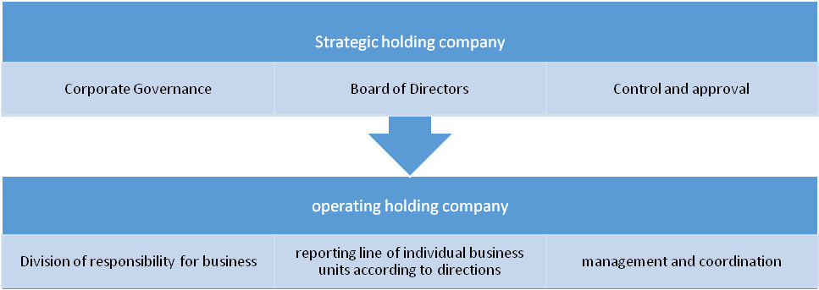

Updating of target organizational structure of the Head office

The new organizational structure of the Head Office was approved in autumn 2016. The competencies of all business lines have been significantly strengthened in the new organizational structure, in accordance with the developed target business processes, in particular, centralization of commercial function, the strengthening of project management function, the change in management of production and repairs. One of requirements for transition to the new organizational structure is introduction of a single approach to selection and deployment of staff based on the principle of meritocracy (Job matching).
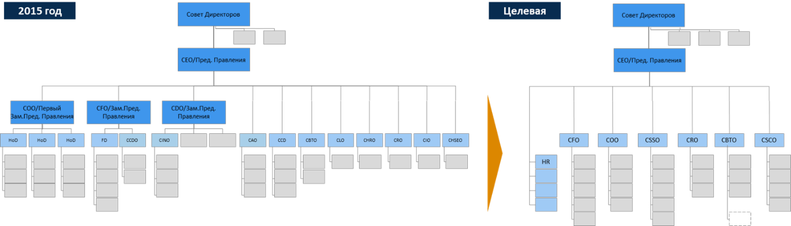
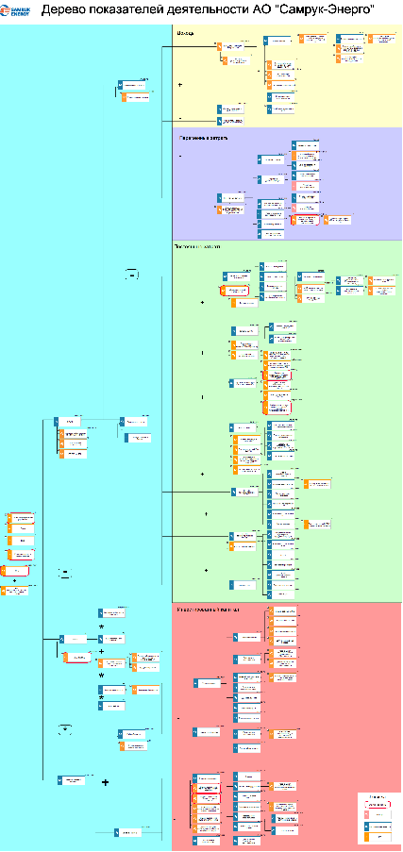

Development of performance and KPI management system

The process of performance and KPI management was developed in 2016. 1st level KPI were set, the value tree was developed and cascading of KPI was conducted . KPI tree for 2017 was digitized in accordance with the approved Business Plan of the Company

Reengineering and automation of business processes and management systems

The Company developed the process model of processes map, designed and harmonized 800 processes in ARIS system during the reporting period. The reference models of “Samruk-Kazyna” JSC for corporate processes were applied as a basis in the development of processes.

Ensuring "quick wins", the first results of special projects "Integrated Planning System".
A pilot model was prepared on the basis of “Ekibastuz SDPP-1” LLP. All required preparatory works were carried out in order to ensure that pilot model has data and algorithms.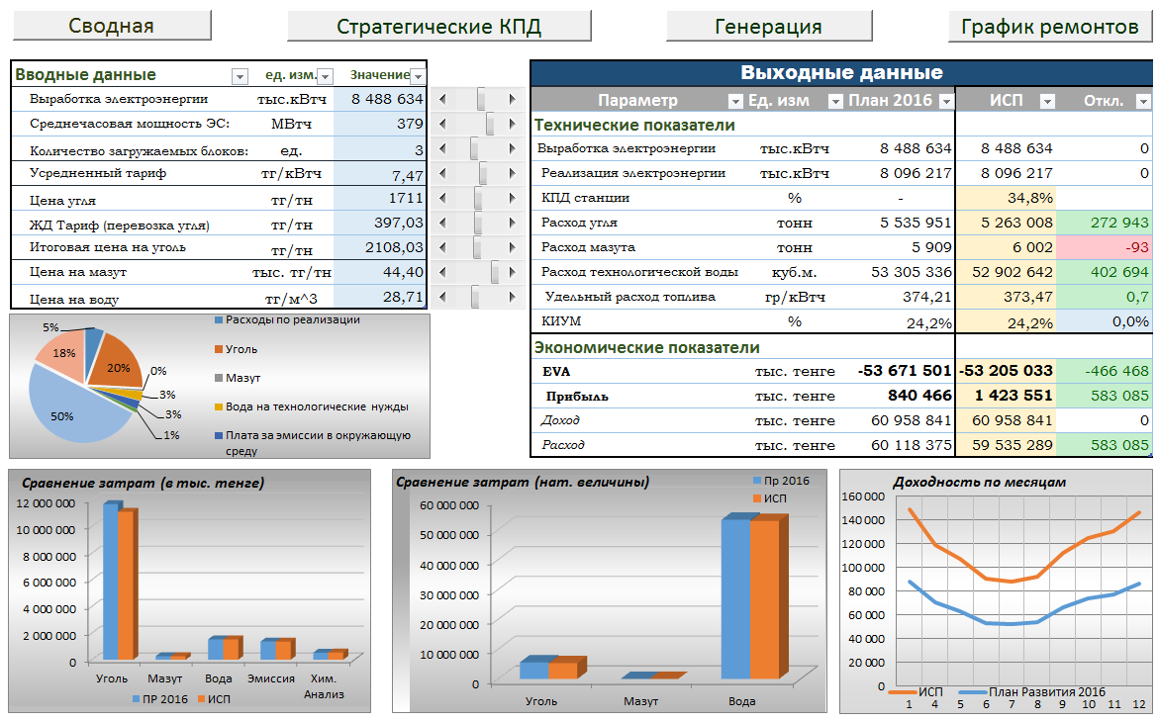

"Release of remainder of inventory after projects". Remainder of inventories in the amount of 7 456 bln.tenge were identified following the results of taking inventory; of which, inventories for the amount of 4,9 bln. tenge were used and disposed in operations in 2015-2016.
"Creation of unified directories of I priority enterprises (materials, services, suppliers, customers). A unified directory with 87 000 unique records was created through processing primary 217 000 records.
Establishment of Competence center
“Energy Solutions Center” LLP was established in 2016, to which the “Data Management Office” was outsourced.
The main result of Transformation Program implementation for 2016 is formation of projects portfolio which includes 12 corporate reference, 4 sector-based business processes and one project relating to organizational structure of the Company.

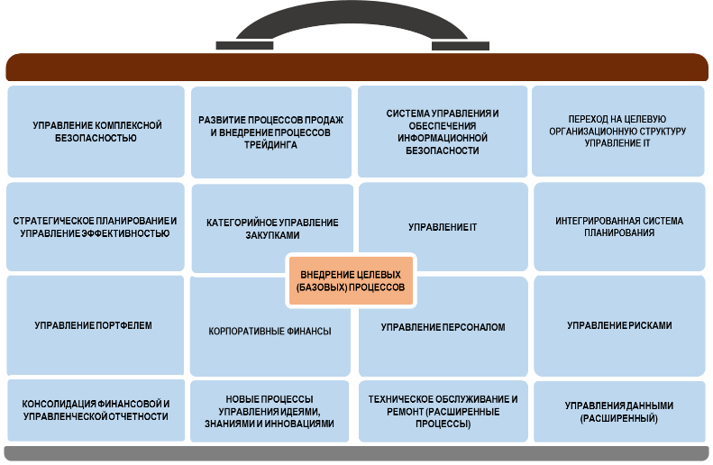

A Sponsor from among the Company's executives was appointed for each project in order to ensure successful implementation of projects portfolio and assignment of responsibility.
Our ultimate common strategic goal is: to build a client-oriented, competitive operating holding company capable of effectively implementing the approved long-term development strategy and ensure meeting the expectations of a sole Shareholder, including enhancing the value and manageability of the company.

As part of achievement of the company’s strategic goal of high-tech development, leadership in the Republic of Kazakhstan and effective monetization of excess capacity for export, the Company plans to implement a number of investment projects:
- modernization of "Shardarinsk HPP" JSC with the date of commissioning in 2018. The implementation of the project will increase the capacity of Shardarinsk HPP by 26% to 126 MW, and will extend the life of the hydropower plant by 35-40 years.
- The company is planning an ambitious development in the field of alternative energy sources. The company plans to introduce up to 10% of renewable energy: wind power, SPP and mini-HPP from its own installed capacity. This will make it possible to become a sustainable leader of green energy in the Central Asian region.
Currently, a number of power plants with a total capacity of more than 0.85 GW are planned or under construction.

- Basic principles of accounting policy and evaluation

For the purposes of a unified approach, in the preparation of a report on the results of financial and economic performance, “Samruk-Energy” JSC group uses the equity method in consolidation.
Based on the above, when using the equity method in the consolidated balance sheet, the turnover of such large companies as "Station ESDPP-2" JSC, the company comprising coal assets "Forum Muider B.V.", where “Samruk-Energy” JSC owns 50% is excluded.
When forming the consolidated financial result of “Samruk-Energy” JSC, the share of profits for these companies is reflected in the article "Share of profit / loss of organizations accounted for using the equity method". In addition, the financial result of the associate company “Balkhash TPP" JSC in terms of ownership of 50% -1 share is reflected in the shared profit.
Acquisition of subsidiaries is accounted for using the purchase method and subsidiaries are evaluated at their fair value at the acquisition date.
Investment property includes the property of “Samruk-Energy” JSC group of companies which is intended to receive rental income or to increase the cost of capital, and is not used by the group itself. Investment property is reflected at the initial cost less accumulated depreciation and provision for impairment.
In accordance with current accounting policy, the fixed assets and intangible assets are reflected at initial cost minus accumulated depreciation and provision for impairment, if necessary.
Depreciation of property, plant and equipment is calculated using the straight- line method to allocate their cost to its residual value, over their estimated useful lives. All intangible assets are depreciated by a straight-line method.
At the end of each reporting period, management determines whether there is evidence of impairment of property, plant and equipment. If at least one such indication is identified, management estimates the recoverable amount. The carrying amount of the asset is reduced to its recoverable amount.
Transactions in foreign currencies are recalculated into the national currency at official exchange rates at the date of a transaction. Foreign exchange gains and losses resulting from the settlement of such transactions and recalculation of monetary assets and liabilities denominated in foreign currency at exchange rates at the end of the year are recognized in profit and loss.
Financial instruments are reflected at fair value, cost, or amortized cost, depending on their classification.
Loans are reflected at amortized cost using the effective interest method. Borrowing costs directly attributable to the acquisition, construction or production of assets are capitalized.
Goodwill is accounted at prime cost less accumulated impairment losses. Goodwill is tested at least once a year.
An asset that is retired or classified as held for sale is recorded In a discontinued operation; This asset can represent a significant activity, and be part of a single plan for the disposal of assets of the Company’s group.

Results of operations and significant factors affecting operations.

Revenues from sales of products and services provided by the Samruk-Energy Group of Companies in 2016 amounted to KZT181,310 million. The decrease of 1.2% compared to the same period last year is mainly due to a decrease in revenue from electricity generation.

No. | Indicator, mln.tenge | 2015⁽¹⁾ | 2016 | 2017  (forecast) | 2018  (forecast)
1 | Income from sales of products and services provided | 183 822 | 181 310 | 204 388 | 249 871
1.1. | Electricity generationi | 127 828 | 124 085 | 133 367 | 164 936
1.2. | Sale of electricity by energy supplying organizations | 88 215 | 90 284 | 94 392 | 106 363
1.3. | Heat production | 13 659 | 13 991 | 17 161 | 18 833
1.4. | Electricity transmission and distribution | 32 095 | 33 448 | 36 477 | 41 609
1.5. | Chemically treated water sales | 1 671 | 1 662 | 1 671 | 1 693
1.6. | Building and installation, repair works | 0 | 0 | 0 | 0
1.7. | Lease | 2 565 | 3 504 | 3 536 | 3 535
1.8. | Others | 950 | 778 | 763 | 931
2 | Net cost of sales of products and services rendered | 128 695 | 136 127 | 157 070 | 180 252
2.1. | Net cost of electricity production | 83 000 | 91 658 | 99 437 | 111 506
2.2. | Net cost of electricity by energy supplying organizations | 88 066 | 88 644 | 93 304 | 105 285
2.3. | Net cost of heat production | 13 430 | 13 699 | 16 674 | 17 973
2.4. | Net cost of electricity transmission | 25 375 | 26 506 | 28 812 | 31 650
2.5. | Net cost of chemically treated water sales | 1 645 | 1 614 | 1 666 | 1 703
2.6. | Net cost of building and installation, repair works | 0 | 0 | 0 | 0
2.7. | Net cost of other core operations | 111 | 215 | 10 | 11
 | Depreciation of fixed assets and intangible assets | 35 290 | 41 053 | 43 144 | 45 089
3 | Gross profit | 55 127 | 45 184 | 47 318 | 69 619
4 | Finance income ⁽³⁾ | 2 876 | 3 396 | 0 | 1
5 | Other income ⁽²⁾ | 3 703 | 6 061 | 459 | 460
6 | Costs related to sales of products and services provided | 2 919 | 3 017 | 4 550 | 5 984
7 | General and administrative expenses | 12 199 | 12 826 | 12 824 | 12 216
8 | Interest expenses ⁽⁴⁾ | 22 164 | 19 218 | 25 791 | 25 699
10 | Other expenses from non-core operations ⁽²⁾ | 93 088 | 2 056 | 176 | 415
11 | Share of profit / loss of organizations accounted for using the equity method | -10 173 | 4 895 | 3 610 | 3 356
12 | Profit (loss) from discontinued operations | 5 975 | 2 494 | 7 337 | 0
13 | Corporate income tax expenditures | 4 583 | 6 521 | 4 750 | 9 569
14 | Minority interest | 390 | 632 | 240 | 232
15 | Total profit attributable to the Group's Shareholders | -77 835 | 17 759 | 10 393 | 19 321
(1) Comparative information was recalculated in order to show the result of transition to discontinued operations;
(2) In the audit report of 2015, the income from “impairment loss compensation” is separated from other incomes, and the impairment loss is divided from the other costs to the separate line “Impairment losses” (net);
(3) In the audit report, the currency difference balance of 2016 is reflected in “financial income” section;
(4) In the audit report of 2015, foreign exchange losses are reflected in “financial income” item.
Note: Incomes and net cost by types of activities is provided without taking into account elimination.

1,2%
A significant share of revenues is made up of revenues from the sale of electricity by energy producing companies, production volumes of which amounted to more than 22, 5 bln. kWh in 2016
Also, a large share in revenues is occupied by revenues from the sale of electricity by energy supplying organizations, sales of which amounted to more than 8,4 billion kWh in 2016, and from the provision of electricity transmission and distribution services in the amount of 12,1 billion kWh.

2016 Income composition by core business lines

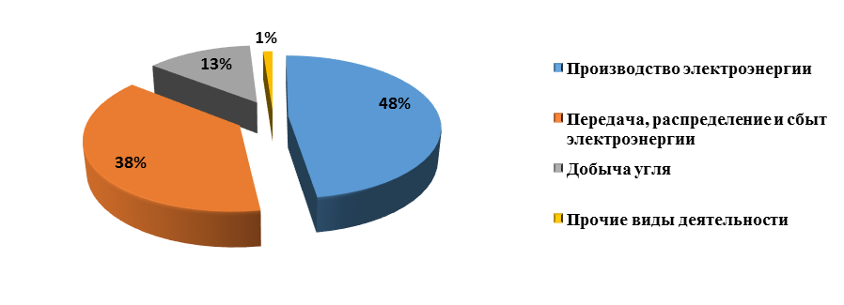

Forecast for the future period: the sales revenue in the forecast for 2017 is planned in the amount of 204 388 mln.tenge with growth by 13% by 2016 due to the increase in volumes of electricity production, transmission and heat production.
INCOME FROM SALES OF PRODUCTS AND PROVISION OF SERVICES BROKEN DOWN BY PRODUCERS
Indicator, mln.tenge | 2015  actual | 2016  actual | 2017  (forecast) | 2018  (forecast)
Income from sales of products and services provided | 183 822 | 181 310 | 204 388 | 249 871
“Samruk-Energy” JSC | 16 040 | 8 417 | 29 937 | 34 859
“Green Energy” LLP | 109 | 113 | 116 | 121
“Bukhtarminsk HPP” JSC | 2 564 | 3 503 | 3 536 | 3 535
“Shardarinsk HPP” JSC | 2 085 | 3 157 | 2 988 | 3 528
“Moynak HPP” JSC | 8 023 | 9 919 | 8 669 | 8 678
“AlmatyEnergoSbyt” LLP | 88 215 | 90 284 | 94 392 | 106 363
“AZhC” JSC | 32 662 | 33 848 | 36 709 | 41 965
“APP” JSC | 53 175 | 60 761 | 56 552 | 58 233
“ESDPP-1” LLP | 78 249 | 62 729 | 79 905 | 110 687
“FWPP” LLP | 1 741 | 3 435 | 4 500 | 4 790
“Karagandagiproshakht and K” LLP | 160 | 0 | 0 | 0
Energy Solution center |  | 334 | 0 | 0
Intercompany balance (elimination) | -99 201 | -95 190 | -112 915 | -122 889

The main share in the Company's operating income is made up of "SDPP -1" LLP, C "APP" JSC, "AZhC" JSC, "AlmatyEnergoSbyt" LLP. At the same time, intercompany balances are excluded mainly in respect of energy sales companies at consolidation of revenues from the total amount.

NET COST OF PRODUCTS AND PROVISION OF SERVICES

Indicator, mln.tenge | 2015 actual | 2016 actual | 2017  plan | 2018  plan
Fuel | 32 906 | 31 524 | 38 244 | 42 838
Depreciation of fixed assets and amortization of intangible assets | 35 290 | 41 053 | 43 144 | 45 089
Labor remuneration and related expenses | 20 377 | 22 334 | 20 110 | 21 234
Cost of purchased electricity | 5 349 | 4 822 | 10 164 | 17 094
Power transmission services and other services | 9 158 | 10 051 | 9 247 | 12 178
Repair and maintenance | 4 835 | 3 951 | 6 776 | 8 922
Taxes except for income tax | 5 770 | 5 955 | 9 515 | 11 039
Water for process needs | 3 933 | 3 835 | 4 438 | 4 898
Materials | 4 414 | 4 843 | 1 015 | 1 278
Thrid party organizations services | 3 970 | 4 896 | 10 806 | 11 525
other | 2 693 | 2 863 | 3 612 | 4 156
TOTAL | 128 695 | 136 127 | 157 070 | 180 252

The main changes occurred in the following types of expenditures:
Fuel, OL, energy: The decrease in fuel costs is due to a decrease in production volumes of SDPP-1 by (-2,035) mln.tenge (or 16% compared to the fact of 2015) due to a decrease in demand. Also, the decrease is due to the increase in ICB between AES and APP taking into account the growth in the output of APP owing to Kapchagay HPP (- KZT2,073 million). At the same time, the expenses for purchasing electricity from RES (+ 919) million tenge are growing. The increase in prices for gas, coal, transportation led to an increase in fuel costs for APP by (+ 1 015) million tenge.
Repairs: Reduction of repair works in connection with conducted surveys on the actual need for repairs and, accordingly, a change in the schedule of repair work with a shift to the right (EGRES-1, APP).
Transmission and sale related services: The increase in expenditures for KEGOC services is due to the annual increase in tariffs (transmission services tariff growth by 7%, dispatching services tariff increase by 27%), as well as an increase in the output of Kapchagay HPP of “APP” JSC due to the high water content of the water reservoir in 2016 (in the case of production at other CHP, KEGOC services are not added to an ultimate consumer).
Labor costs for production personnel: The increase is due to annual indexation under the collective agreement of subsidiaries and affiliates.
Other production works, services and lease increase in respect of the item "Maintenance of production equipment" is connected with conclusion of the agreement for SS-220/35 kV substation "WPP Ereymentau1" maintenance with “FWPP” LLP in 2016.
Other: Increase in costs for raw materials and supplies (chemical agents and beaters) at “SDPP-1” LLP, due to replacement of materials on filters of the regenerator. Also in comparison with 2015 there was a rise in price of purchased services and materials.

.
Net cost structure by core business lines
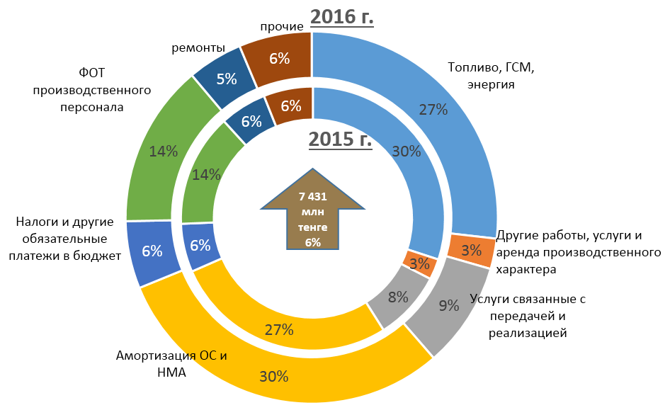

Forecast for the future period: In the forecast for 2017, the cost of sales and services rendered increases by 20 943 mln.tenge (15%). The main increase is associated with an increase in fuel costs, due to the increase in electricity production and the annual increase in prices for purchased fuel, depreciation due to assets upgrading and purchased electricity from renewable energy sources. And also growth is connected with an annual increase in staff salaries taking into account the inflation factor and an increase in prices for services rendered by third-party organizations. In the forecast for 2018, expenses for net cost are also increasing due to the above reasons.
Sales cost

Indicator, mln.tenge | 2015 | 2016 | 2017 (forecast) | 2018 (forecast)
The costs of labor and social benefits of personnel associated with sales process | 12 | 13 | 13 | 14
Taxes other than income tax | 1 | 1 | 2 | 2
Other services and works associated with sales | 2 906 | 3 003 | 4 536 | 5 969
Other sales costs | 0,03 | 0,04 | 0,05 | 0,05
TOTAL | 2 919 | 3 017 | 4 550 | 5 984
According to results of 2016, sales costs increased by 98 mln. tenge in connection with “ESDPP-1” LLP electricity export to Kyrgyzstan.
In the forecast for 2017, the increase in sales costs compared to the fact of 2016 will be 51%, a significant increase is due to an increase in the cost of dispatching services and the organization of balancing the electricity production and consumption by “ESDPP-1” LLP due to increased volumes of electricity generation and export of electricity to Kyrgyzstan.

Administrative expenses

Indicator, mln.tenge | 2015  actual | 2016  actual | 2017  actual | 2018  actual
Remuneration of labor and related expenses | 4 300 | 4 712 | 5 004 | 5 291
Consulting and other professional services | 1 019 | 1 615 | 1 323 | 779
Taxes other than income tax | 893 | 1 024 | 725 | 784
Rent expenses | 653 | 628 | 479 | 290
Depreciation of fixed assets and amortization of intangible assets | 1 196 | 1 187 | 1 083 | 1 095
Business trip and representation expenses | 245 | 221 | 248 | 262
Bank services | 190 | 185 | 135 | 142
Communication expenses | 115 | 119 | 160 | 170
other | 3 588 | 3 134 | 3 666 | 3 402
Total | 12 199 | 12 826 | 12 824 | 12 216

Administrative expenses for the end of 2016 amounted to 12 826 mln.tenge, which is higher than the fact of 2015 by 628 mln.tenge or 5%, due to the annual indexation of wages under the collective agreement of SA, as well as an increase in consulting expenses in 2016 related to transformation project.
Forecast for the future period: In the forecast for 2017 administrative expenses remain at the level of 2016 and amount to 12 824 mln.tenge.
In the forecast for 2018 administrative expenses will decrease due to the exclusion of assets intended for sale.
Interest expenses

Indicator, mln.tenge | 2015 | 2016 | 2017 (forecast) | 2018 (forecast)
Borrowing costs | 22 165 | 19 218 | 25 791 | 25 699

.
(1) In the audit report of 2015 financial expenses are shown together with a foreign exchange loss.

According to results of 2016 interest expenses amounted to 19 218 mln. tenge, which is lower than the actual value for 2015. The decrease was mainly in HO and Moynak HPP due to the strengthening of the national currency from 340.01 tenge / US dollar as of December 31, 2015, drop in exchange rate as of December 31, 2016 the rate was 333,29 tenge / US dollar.

Forecast for the future period: In the forecast until 2017 interest expenses grows taking into account the increase in the interest rate on the bonded (in US dollars) loan of the HO taking into account the refinancing of the currency loan into a loan in national currency.

Share of profits of joint ventures and associated companies
Indicator, mln.tenge | 2015  actual | 2016  actual | 2017  plan | 2018  plan
Share of profit of joint ventures and associated companies | -10 173 | 4 895 | 3 610 | 3 356
Forum Muider | 5 058 | 6 020 | 5 051 | 6 497
“Ekibastus SDPP-2” JSC | -12 768 | 788 | -1 442 | -3 141
“Balkhash TPP” LLP | -2 463 | -1 913 | 0 | 0

The shared profit for the year ended 31 December 2010 was 4047mln.tenge, increased by 14 219 mln tenge compared to the same period.
The main changes occurred in the following assets:
ESDPP-2 - an increase by 13553 mln.tenge compared to the previous year is due to the following factors:
- an increase in income from core operations by 2 809 mln.tenge, owing to the increase in electricity generation, revenue growth by 7 480 mln.tenge in connection with exports to the Russian Federation, and a decrease in revenues due to reduction in the weighted average tariff by 4 671 mln.tenge taking into account the low tariff for electricity exports to the Russian Federation;
- reflection in 2015 of the negative exchange rate difference under the project “Expansion and reconstruction of Ekibastuz SDPP-2 with installation of the power unit st. No.3” according to the loan agreement in the amount of 18 883 mln. tenge.
Forum Muider - a 961 mln.tenge increase was mainly due to the absence of foreign exchange losses in 2016 compared to 2015, reduction in interest expenses and lowering of depreciation for revaluation to fair value (adjustment at the consolidation level).
Balkhash TPP - reduction in BTPP loss by 551 million tenge is due to the positive exchange rate difference for 2016.
In the plan for 2017-2018 the decrease in profits from companies accounted for under the equity method is mainly due to the increase in interest expenses of “Ekibastuz SDPP-2” JSC.
Profit (loss) from discontinued operations
Indicator, mln.tenge | 2015 actual | 2016 actual | 2017 plan
Profit from discontinued operations | 5 975 | 2 494 | 7 337
“MDPGC” JSC | 978 | 1 533 | 862
“Aktobe CHP” JSC | 348 | 397 | 391
“East Kazakhstan REC” JSC | 1 965 | 1 502 | 1 509
“Shygysenergotrade” LLP | 169 | -941 | 1 669
“Tegis Munay” LLP | -201 | -28 | -28
“Mangyshlak Munay” LLP | -22 | -187 | -157
Income from sale of ZhSDPP | 2 469 | 0 | 0
Intercompany balance (elimination) | 267 | 218 | 3 091

According to the results of the year assets intended for sale including “Tegis Munay” LLP, “Mangyshlak Munay” LLP, “EK REC” JSC, “Shygysenergotrade” LLP , “MDPGC” JSC, “Aktobe CHP" JSC were shown in the profit from discontinued operations in 2016.
For comparability purposes, the year 2015 was retrospectively recalculated taking into account the classification of these assets as assets subject to sale. The decrease in 2016 is due to the fact that in 2015 the profit from the sale of “ZhSDPP” LLP for 2 469 mln.tenge was reflected, as well as due to a decrease in profit in respect of “Shygysenergotrade” LLP in 2016 by 1 110 mln.tenge in connection with insufficiency of tariff level. The increase in profit in 2017 was due to the increase in profit in respect to "Shygysenergotrade" LLP by 2 610 mln.tenge in connection with planned tariff increase to 12 151 tenge/ kWh, as well as due to the inclusion of depreciation of assets intended for sale into discontinued profit.

- Analysis of capital resources
№ | Subsidiaries and affiliates | 2015 | 2016 | 2017 | 2018
 |  | actual | actual | plan | plan
 | TOTAL | 89 720 | 79 061 | 83 934 | 55 743
1 | Investment projects, including | 46 948 | 41 810 | 44 805 | 28 871
1.1 | Rehabilitation of power unit 1 with installation of new ESP | 3 439 | 5 296 | 5 622 | 3 861
1.2 | Rehabilitation of power unit 2 with installation of new ESP | 2 909
1.3 | Upgrading of 500 kV OS | 4 539 | 9 805
1.4 | Expansion and reconstruction of Ekibastuz SDPP-2 with installation of power unit No.3 (50%) | 4 184 | 4 008 | 472
1.5 | Transition to cyclical and continuous method of mining, transportation, blending and loading of coal at “Bogatyr” open-pit mine (50%) | 226 | 30 | 7 747 | 10 871
1.6 | Development of power networks in Karasay district with construction of “Shamalgan” (Ushkonir) and SS “Station Shamalgan” with transfer of load from nearby SS 35/10 kV | 11 | 58
1.7 | Transfer of load of 220/110/10 kV SS “Gorny Gigant” No.131 A to 220/110/10 kV SS “Yermensay” through 110 kV grids with subsequent dismantling of SS-131 A |  | 340 | 2 592
1.8 | Reconstruction and expansion of Almaty CHP-2. III stage. Boiler unit of station No. 8 | 13 621 | 183
1.9 | Reconstruction of combined ash removal system of CHP-2 | 785
1.10 | Reconstruction and modernization of Aktobe CHP | 396 | 2
1.11 | Construction of Moynak HPP | 526 | 79
1.12 | Modernization of Shardarinsk HPP | 1 762 | 8 988 | 20 023
1.13 | Construction of 45 MW WPP “Ereymentau” (1st stage) | 6 352
1.14 | Construction of 50 MW Ereymentau ( II stage) | 364 | 145 | 5 207 | 14 093
1.15 | Construction of GTPP based on Pridorozhnoe gas field | 2 072 | 426 | 681
1.16 | other projects | 5 762 | 12 450 | 2 461 | 46
2 | Maintenance of production assets | 39 304 | 35 731 | 32 639 | 25 828
2.1 | “Bogatyr-Komir” LLP (50%) | 1 338 | 1 439 | 3 841 | 3 075
2.2 | “SESDPP-2” JSC (50%) | 732 | 17 | 230 | 671
2.3 | “ESDPP-1” LLP | 19 532 | 16 787 | 4 845 | 3 486
2.4 | “Alatau Zharyk Company” JSC | 8 708 | 9 312 | 11 484 | 13 182
2.5 | “Almaty Power Plants” JSC | 3 663 | 1 681 | 4 269 | 3 536
2.6 | “Aktobe CHP” JSC | 1 082 | 392 | 905
2.7 | “Moynak HPP” JSC | 278 | 1 084 | 351
2.8 | “Shardarinsk HPP” JSC | 51 | 124 | 151 | 1 836
2.9 | “Mangistau REC” JSC | 365 | 2 027 | 3 390
2.10 | “AlmatyEnergoSbyt” LLP | 76 | 68 | 37 | 42
2.11 | “Samruk-Green Energy” LLP | 3 | 3 | 1
2.12 | “First Wind Power Plant” LLP | 52 | 24 | 6
2.13 | “EK REC” JSC | 3 391 | 2 740 | 3 105
2.14 | “Shygysenergotrade” LLP | 33 | 33 | 24
3 | Maintenance of administrative assets | 2 320 | 1 411 | 1 018 | 1 045
4 | others | 1 148 | 109 | 5 472

The Projects implemented in 2016
The project "Reconstruction and Modernization of Aktobe CHP" was completed in May 2016. The project is aimed at increasing the installed capacity and increasing the reliability of electricity supply to consumers in the Aktobe region by installing the new 30 MW turbine.
The reconstruction of the boiler unit of Almaty CHP-2 st. No.8 completed in September 2016. The project is aimed at covering the expected increase in heat loads, providing the Universiade 2017 facilities with heat and increasing the installed heat capacity to 1 414 Gcal/h, 450 million kWh electricity generation by Almaty CHP-2.
The modernization of 500 kV outdoor switchgear at Ekibastuz SDPP-1 was completed in November 2016 in order to improve reliability by replacing obsolete equipment (switches, transformers, disconnectors) as well as to increase the service life of equipment.
The projects that are planned to be completed in 2017
For reliable and uninterrupted power supply to the growing loads in the northern part of Almaty city, a project on construction of a 110/10 kV “Turksib” substation with a transformer capacity of 80 MVA will be completed in June 2017.
The project “Transfer of load of 220 kV SS Gorny Gigant to 220 kV SS Yermensay through 110 kV grids with subsequent dismantling of SS Gorny Gigant” will be implemented in December 2017. The project is implemented to improve the reliability of electricity supply to consumers.
The projects that are planned to be completed in 2018
The project "Development of power networks in Karasai district with construction of 110 / 10kV Substation “Shamalgan” (Ushkonyr) and 110 / 10kV SS "Shamalgan Station" with transfer of loads from nearby 35 / 10kV substations” is planned to be completed in October 2018. The project assumes an increase in the reliability of power supply to consumers in Karasai and Zhambyl districts of the Almaty region, as well as a reduction in electricity losses in power grids.
Upgrading of Shardarinsk HPP will be completed in December 2018. The Project will allow increasing the installed capacity of the plant from 100 MW to 126 MW.

Liquidity
Performance of covenants from external creditors

Covenant | standard | 2016  actual | Deviation | Notes
Debt/EBITDA (ЕBRD) | Not more than 4,5 | 5,4 | 0,90 | The established limit is exceeded, but the Company received a letter-consent (waiver) for this covenant for 2016 from the EBRD
EBITDA/interest (EBRD Shardarinsk HPP) | Not less than 3 | 3,77 | 0,77 | observed
Debt/Equity (KDB) | Not more than 1 | 0,75 | 0,25 | observed
Consolidated adjusted EBITDA / Net consolidated financial payments (Eurobonds) | Not less than 3 | 5,05 | 2,05 | observed
Liquidity and financial stability indicators
Description | 2015 | 2016 | 2017 (forecast) | 2018 (forecast)
Debt/EBITDA | 5,26 | 5,41 | 4,78 | 3,35
Debt/equity | 0,83 | 0,75 | 0,68 | 0,69
Current liquidity | 1,39 | 0,66 | 1,56 | 0,76

In general, the change in key financial and operating figures as follows influenced the liquidity and financial stability figures.
The debt / EBITDA indicator for 2016 was 5,41, which exceeds the covenant established by the European Bank for Reconstruction and Development, that is not more than 4.5, under the Loan agreement with Shardarinsk HPP, where the Company is a co-borrower.
As part of activities on meeting the covenant, in 2016, after a series of negotiations with the EBRD, the Company received a letter of consent (Waiver) to exceed the set value for the covenant Debt / EBITDA for the first half and the end of 2016 without specifying a threshold.
In order to ensure financial stability and compliance with the Company's covenant in the conditions of unstable economic situation and volatility of financial market, the Company regularly monitored the attraction of funding across the group during 2016. As a result of actions taken, the Company managed to ensure compliance with financial covenants, reduce the debt burden and improve financial stability.
The debt / EBITDA indicator is planned at 4.78 in 2017. The change in the indicator was due to an increase in EBITDA by 3.6% and a decrease in debt by 8.5% compared to 2016. The reduction in debt is due to the refinancing of the Company's Eurobonds. In 2018 this indicator improves up to 3,35 due to repayment of Eurobonds.
The financial leverage ratio (Debt / Equity) was 0.75 in 2016, the decrease in the indicator compared to the fact for the same period (by 0,08) was due to the increase in equity capital by 34 076 mln. tenge due to the increase in retained earnings owing to 2016 profit in the amount of 17 759 mln.tenge and a decrease in the borrowed capital by 15 111 mln.tenge in respect of Head office including payment of principal on short-term loans and a decrease in the principal debt on Eurobonds due to the depreciation of the US dollar and in respect of “MHPP" JSC owing to reduction in US dollar exchange rate as well as the repayment of principal.

This indicator is planned to improve to the level of 0, 68 in 2017, the indicator is projected to increase to 0,69 by the end of 2018, which is due to a decrease in equity capital in connection with the sale of assets.
Current liquidity indicator for 2016 was 0,66, a decline is observed in comparison with the same period due to the allocation of the current portion of the long-term loan on Eurobonds to short-term obligations, this indicator improves to 0.76 until 2018.

5. Contingent liabilities, contractual obligations
Currently, there are no ongoing other legal proceedings or other outstanding claims, the results of which could have a material adverse effect on the future financial position of the Group.
In accordance with environmental legislation, the Company has a legal obligation to restore the site of ash dumps, which are the landfills of waste disposal of the company's operating activities. According to 2016 results, the book value of the reserve for the restoration of the ash dumps amounted to KZT1,637.1 mln. The assessment of the existing reserve for disposal of ash dumps is based on the interpretation of existing environmental legislation of the Republic of Kazakhstan by the Group supported by a feasibility study and engineering studies in accordance with current standards and methods of conducting restoration and remediation works.
Capital liabilities at the end of the reporting period include contractual obligations for the acquisition of fixed assets totaling KZT125,661 million, the percent of shared companies in capital liabilities amounted to KZT 47,115 million.
6. Comparative analysis (benchmarking)
The purpose of benchmarking is to compare operational and financial figures with foreign peer companies in order to determine Samruk-Energy’s strengths and weaknesses. For benchmarking, the following indicators were used:
- EBITDA margin;
- Return on invested capital (ROIC);
- gearing ratio (Debt / Equity)
- Debt / EBITDA

Benchmarking results:

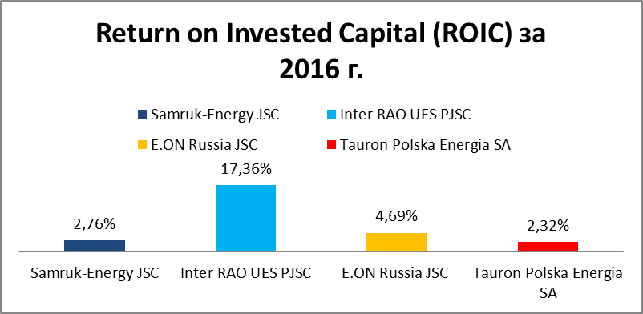
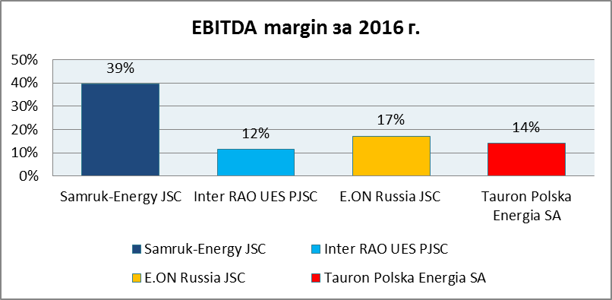
Financial stability indicators | Samruk-Energy JSC | Inter RAO UES PJSC | *E.ON Russia JSC | Tauron Polska Energia SA
Debt/EBITDA | 5,41 | 0,18 | - | 3,74
Debt/Equity | 0,75 | 0,04 | - | 0,55

*E.ON Russia has no debts
Sources: Bloomberg, financial statements of the company
At present, “Samruk-Energy” JSC is inferior in some respects compared with foreign peer companies.
At the same time, according to the EBITDA margin, Samruk-Energy outperforms its peers. This indicator demonstrates a high profitability of sales. In terms of ROIC (return on long-term invested capital), Samruk-Energy is in the middle range, which indicates the need to increase the efficiency (return on investment) of investments.
Financial stability indicators show that Samruk-Energy uses available financial leverage in full.

